Working With the Dataset

**Loading The Dataset**

**Team ID:** PNT2022TMID42593

**Project Name :** Estimate the Crop Yield Using Data Analytics

**Loading the dataset into IBM Cognos**

* Before you can build a view and analyze your data, you must first connect the data to IBM Cognos. Cognos supports connecting to a wide variety of data, stored in a variety of places.
* The data might be stored on your computer in a spreadsheet or a text file, or in a bigdata, relational, or cube (multidimensional) database on a server in your enterprise.
* In our case, we will be using a spreadsheet or text file for making our analysis. Go through the video for understanding the connection of dataset in Cognos.

**GO TO UPLOAD DATA ON THE MENU:**

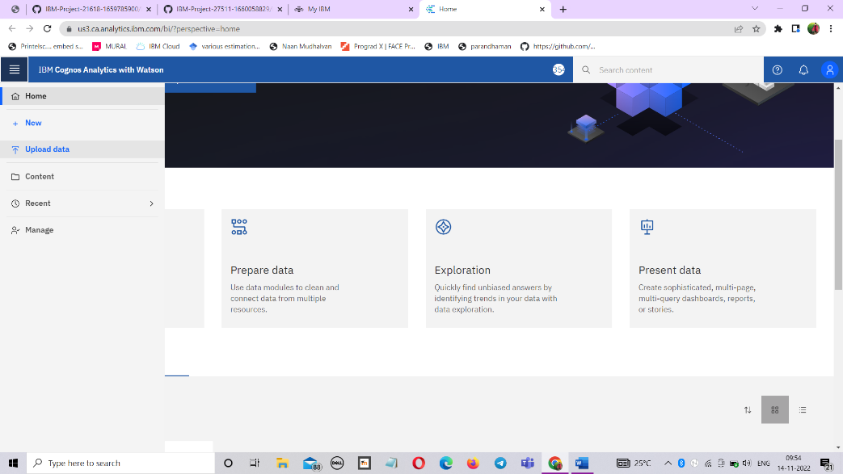

**UPLOAD DATASET INTO UPLOAD DATA COLUMN:**

